**DAILY ONLINE ACTIVITIES SUMMARY**

|  |  |  |  |  |  |  |  |  |
| --- | --- | --- | --- | --- | --- | --- | --- | --- |
| **Date:** | **10-06-2020** | | | | | **Name:** | **Javahar.S.Goutham** | |
| **Sem & Sec** | **7th B sec** | | | | | **USN:** | **4AL1CS132** | |
| **Online Test Summary** | | | | | | | | |
| **Subject** | | **No test** | | | | | | |
| **Max. Marks** | | **-** | | **Score** | | | **-** | |
| **Certification Course Summary** | | | | | | | | |
| **Course** | **Introduction to ethical hacking(completed)**  **RPA(completed)** | | | | | | | |
| **Certificate Provider** | | | **Great Learning**  **GUVI** | | **Duration** | | | 6+3=9h**rs** |
| **Coding Challenges** | | | | | | | | |
| **Problem Statement**: 1. Write a Java program to find the maximum and minimum value node from a circular linked list.  **2.** Write a C Program to print the sum of boundary elements of a matrix.  **3.** Python Program to check whether a given number is a fibonacci number or not. | | | | | | | | |
| **Status: YES, Completed all Programs.** | | | | | | | | |
| **Uploaded the report in Github** | | | | | **YES** | | | |
| **If yes Repository name** | | | | | https://github.com/alvas-education-foundation/Goutham-dotcom | | | |

Online Test Details: (Attach the snapshot and briefly write the report for the same)

No tesst

Certification Course Details: (Attach the snapshot and briefly write the report for the same)

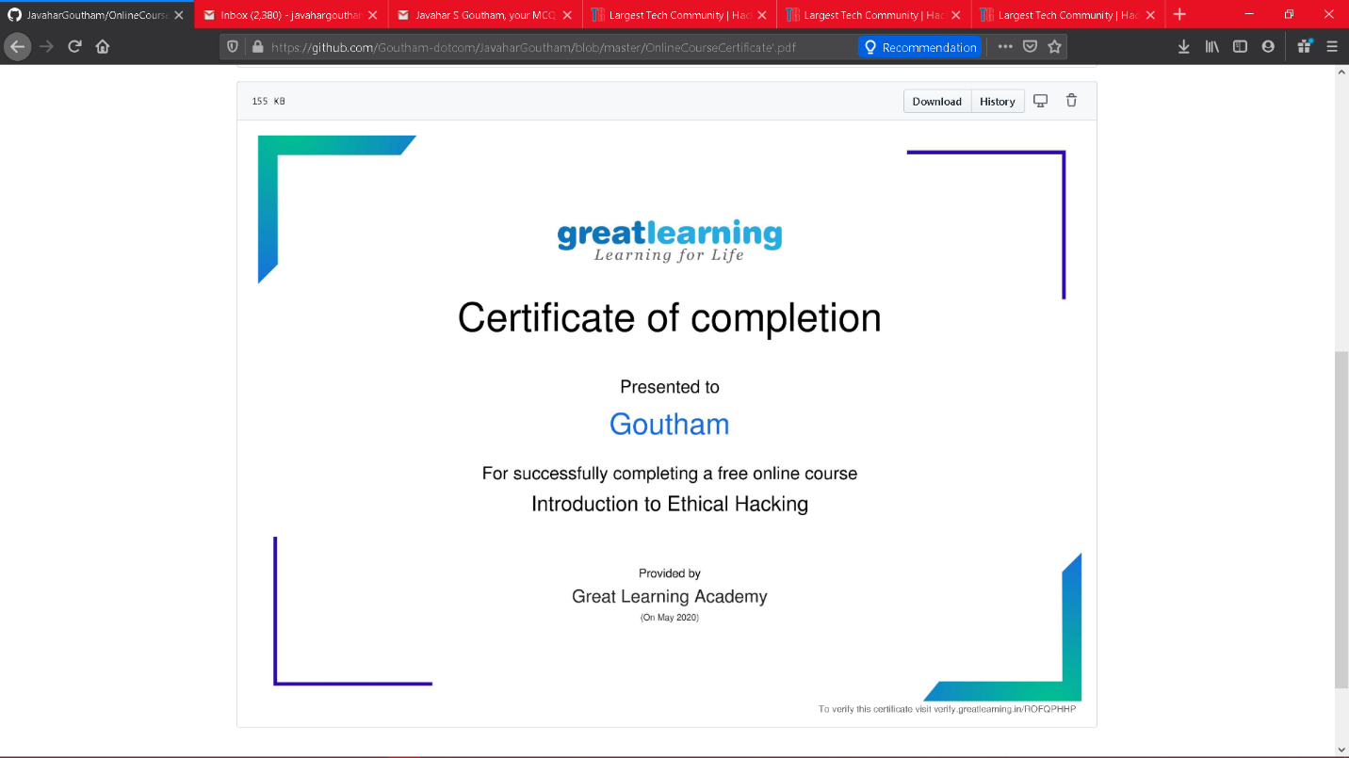

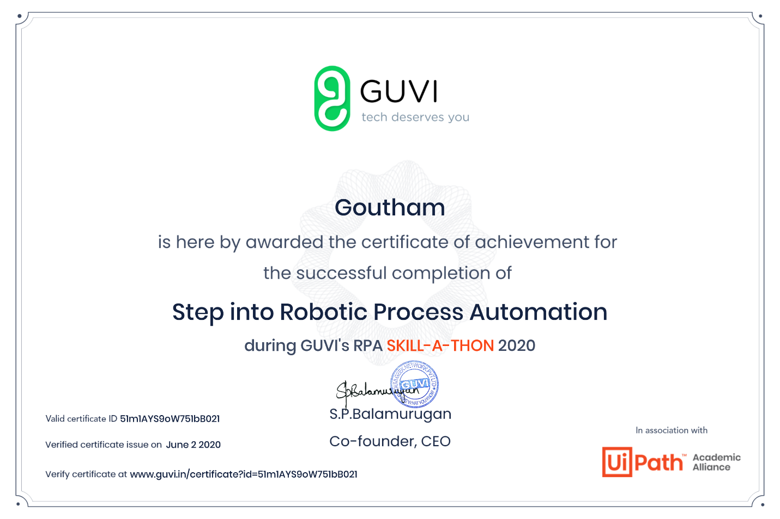

Coding Challenges Details: (Attach the snapshot and briefly write the report for the same)

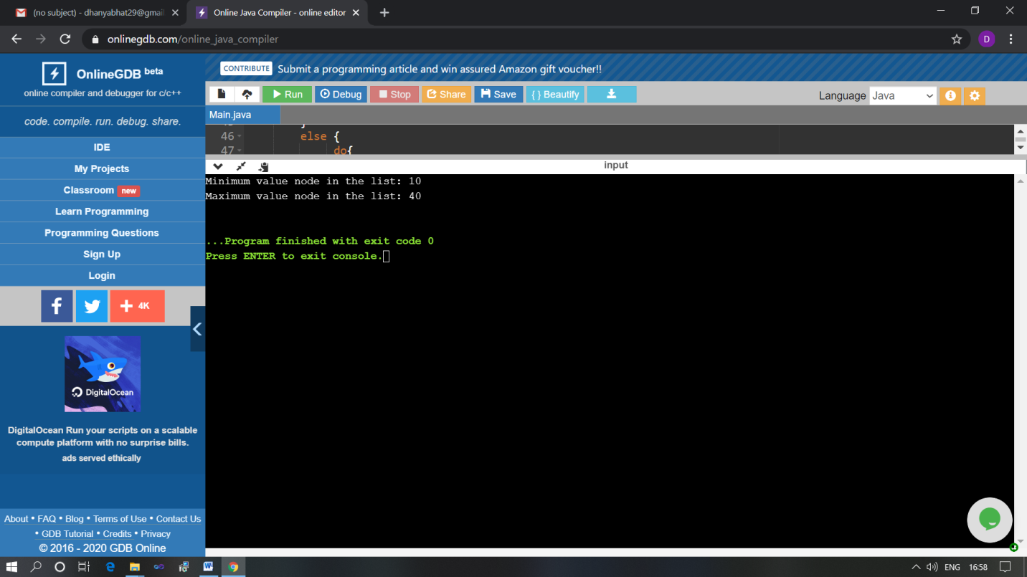

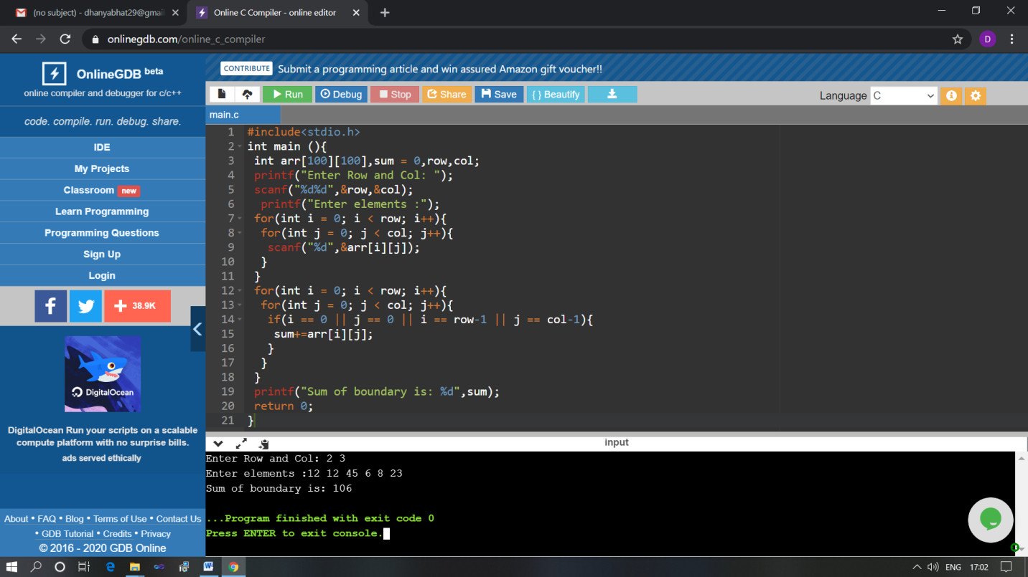

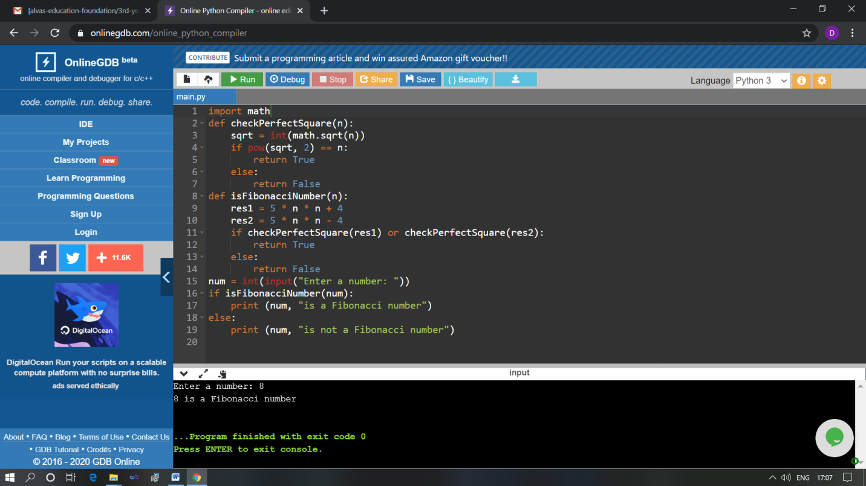

The above Programs were written and executed and the output of the same is displayed above. The code for those 3 programs have been uploaded to the github repository and the link to the same is provided on the form.